Template for the Special Issue on Emerging Mobility Services in Transportation Letters

First Authorª, Second Authorª, Third Author^{b}, Fourth Author^{a,b,*}

ªDepartment, University, Street Address, City, Country
^{b}Company name, Street Address, City, Country
*Corresponding author e-mail: fourth.author@uni.edu

Abstract

Abstract text. The abstract should concisely describe the main contributions of the manuscript and should not contain abbreviations, mathematical notation or references.

Keywords: traffic control; collision avoidance; optimization; autonomous vehicles.

Formatting Guidelines

Manuscripts should not exceed 6 pages in length (double column), including title, abstract, text, figures, tables, and references. The font should be Times New Roman or similar and font size should be 10pt. Electronic file should not exceed 5 megabytes. Manuscripts must be prepared in proper English. SI units or acceptable metric equivalents must be used throughout.

Authors are responsible for ensuring the accuracy of all information contained in their manuscripts (e.g., proper names of organizations, data and findings, references, etc.).

A maximum of 4 sections is imposed. Suggestions for section titles are:

- Introduction

- Method / Formulation / Model

- Results / Numerical Results / Findings

- Discussion / Conclusion
Section 1 should introduce the problem context and position the manuscript in the literature. The review of the literature should be kept concise and incorporated primarily in this section.

Section 2 should present the methodology used in the manuscript to explore a hypothesis, formally define the research problem and accurately describe the proposed solution approach.

Section 3 should summarize the results. The use of figures and tables is recommended.

Section 4 should discuss the findings of this study, identify its limitations and outline possible extensions of the work.

Figures, Tables and Equations

Insert figures and tables as close as possible to their first reference, e.g. see Table 1.

Table 1. Table title and description
$$i$$ | $$j$$ | $$g_{ij}(x)$$
1 | 2 | 15.5
1 | 3 | 20.0
2 | 3 | 10.7

Number figures and tables consecutively using Arabic numerals and center the title. Figures, such as graphs and diagrams, should be embedded in vector format (e.g. .pdf or .emf), if at all possible. Otherwise, figures such as pictures should be with high resolution (300 dpi or above).

A figure or a table too wide to fit between the margins of a single column may span two columns. All figures and tables must have captions, be numbered and be referred to in the text of the manuscript, e.g. see Figure 1.

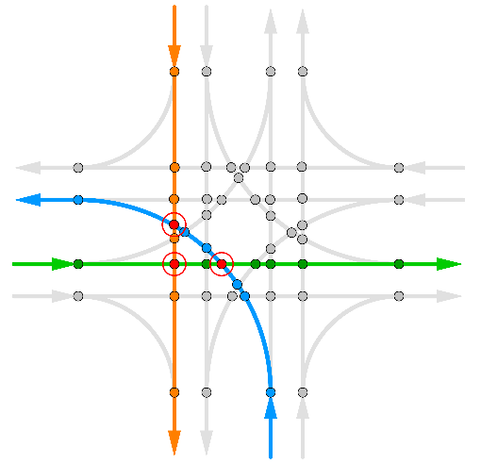

Figure 1. Figure title and description

All Equations should be written using Word equation mode. Equations should be written inline whenever possible, e.g. $f(x) = x^2 -2x +$1. Otherwise, equations should be numbered, e.g. see Equation (1):

$$a^{n}+b^{n}=c^{n}$$ | (1)

Bibliography

The list of references should be placed at the end of the manuscript. It is recommended to use a bibliography management system to handle references, e.g. [1].

References
- Jeffrey Hood, Elizabeth Sall, and Billy Charlton. "A GPS-based bicycle route choice model for San Francisco, California." Transportation letters 3.1 (2011): 63-75.

